Sprint National Anaesthesia Project (SNAP-1)
Online Web Tool User Notes
How to access the online web tool:
- To access the web tool enter the following web address:
https://snap1.snapresearch.org.uk/
- You will see the welcome page below. Click on ‘Login’ found on the top-right corner of the page.
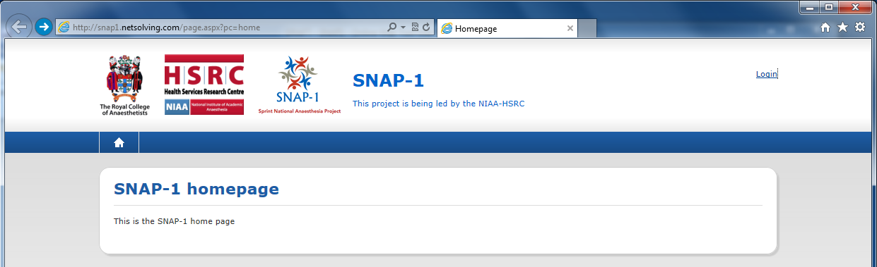
- This will bring you to the ‘Terms of agreement page’. Please read through this section carefully and when you are ready to proceed, select the ‘I accept’ option.
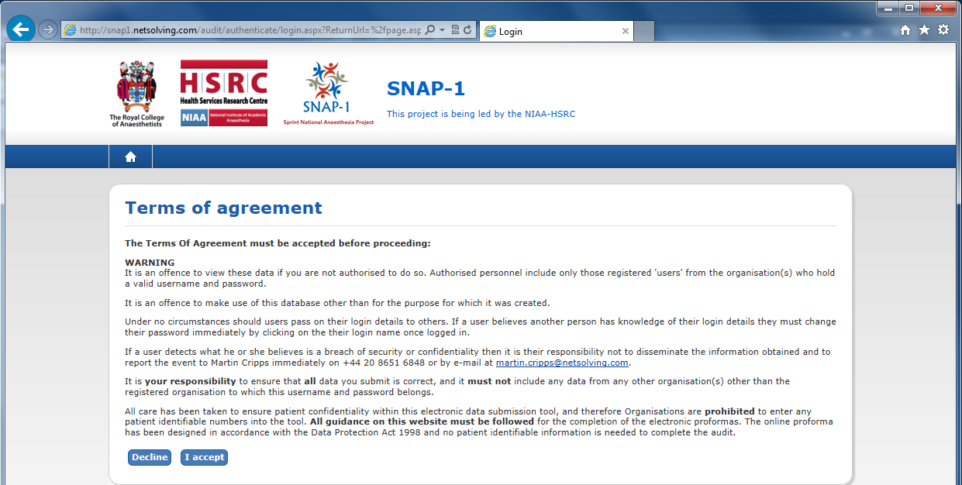
- You will see the Login page below. The first time you access the SNAP-1 web tool we suggest you click on ‘Forgot your password’ and go through the process of creating your own password. It will ask you to enter your email address and it will send you an email containing a password-reset link. Please be sure to enter the same email address with which you initially registered for SNAP-1. When accessing the web tool going forward simply enter your full email address as your username and the password you’ve set for yourself to log in.
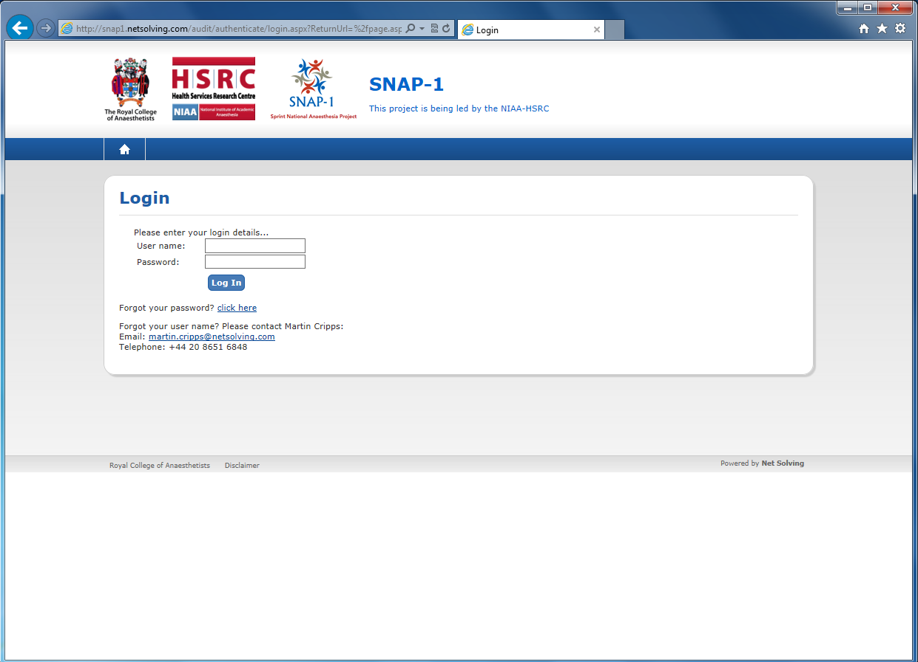

Accessing the questionnaire and record management screen
- To access the project questionnaires select ‘Clinical’ on the tab at top of the screen. 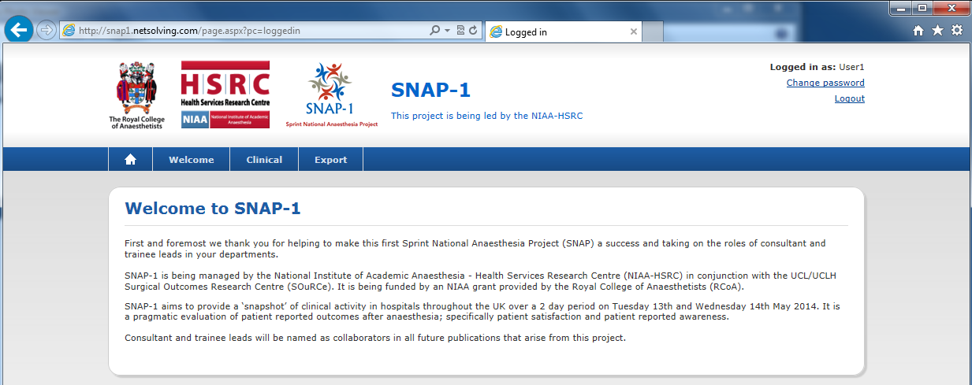
- You will be sent to the project Record Management Screen. This shows you all SNAP-1 cases that have been entered onto the web tool for your trust. Please be aware than any information that is entered for a particular trust will be accessible by all other registered users for that trust.

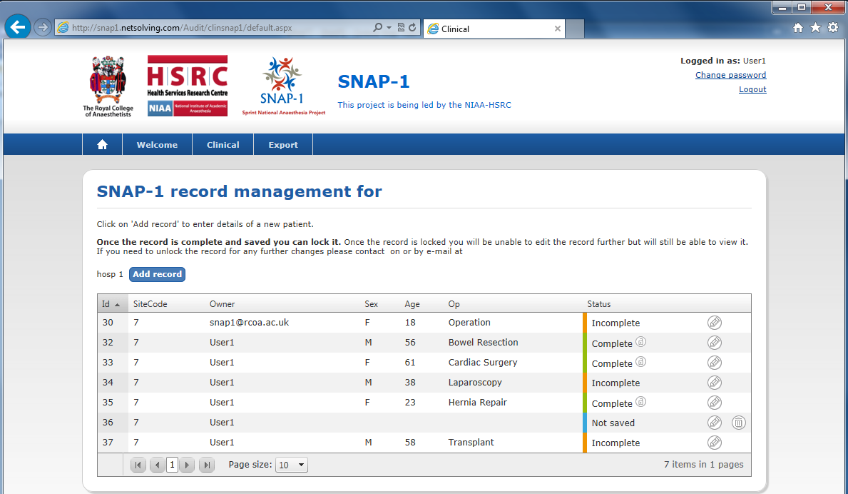

- The Record Management Screen shows you basic information for cases entered such as sex, age and the operation the patient has undergone. Once several cases have been entered they will appear in your Case Management Screen in a list. The Owner column indicates which web tool user created each case. You are also able to see how advanced to being completed each case is by looking at the colour under the Status column. You are able to reorder the list according to owner/patient age etc. by clicking the heading at the top of each column.

Each colour under the Status column represents the current state of the case:
Green – Complete
Orange – Incomplete
Red – Errors
Blue – Not Saved

- To continue updating an incomplete case or make changes to a completed case click on the circled pencil the right of each record. Once a case has been completed and you are confident that no further changes are required, please select the lock icon next to where Complete is indicated. To enter a new case onto the web tool select the ‘Add record’ option.

Entering Data
- When you click on ‘Add record’ you will see the questionnaire screen and can begin entering the patient information. The data collection screen is separated into three sections; Patient demographics, Bauer Patient Satisfaction Questionnaire and Modified Brice Questionnaire.
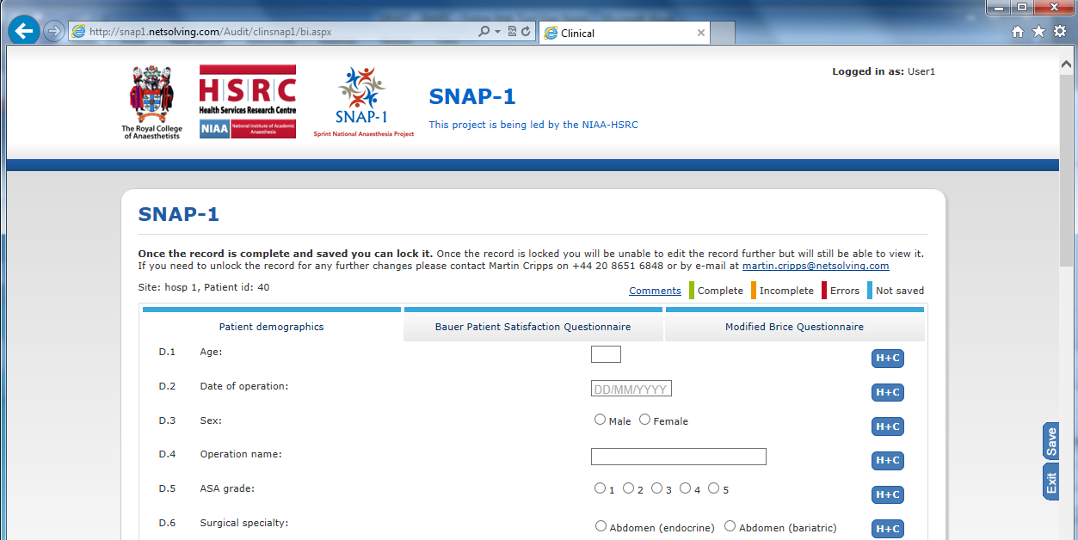
Once you have finished entering data for one of the sections please click on the ‘Save’ button to the right of the page and you can then proceed to the next section. If at any point you need further clarification regarding one of the questions please click on the ‘H+C’ button on the right.
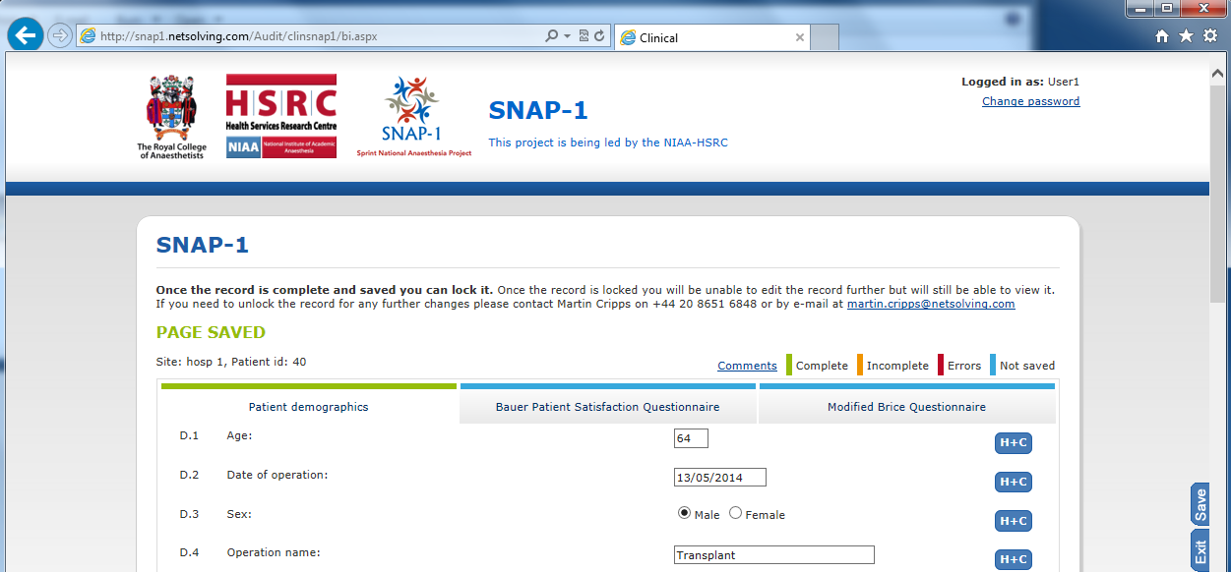
Once you have filled in all the information for the case or you would like to save it as ‘Incomplete’ and return to it later on please make sure you have clicked ‘Save’ and then select the ‘Exit’ button directly below. This will bring you back to the record management screen.
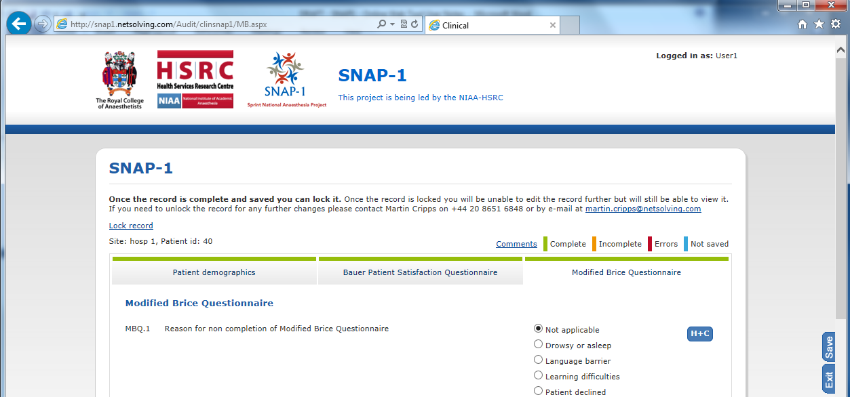
Locking a case
- Once all three tabs have turned green and you are confident that no further changes are needed you are able to lock the case. To do so click on the ‘Lock record’ button; a pop-up box will appear asking you to confirm that you would like to lock the case and once you select ‘OK’ the case will be locked.

